intro to virtualbox

What is VirtualBox
VirtualBox is software that allows you to run virtual machines. This is essentially a full computer, called a guest, running inside the desktop of your current computer, called the host. This is just a basic tutorial on using VirtualBox and will not go into any of the details of virtualization or linux. This is a nice way to try a new operating system, to test out software, or to do something that may not be compatible with your host computer.

*Please note that these instructions say to use 64 bit, 1 gigabyte of ram, and 2 cores. If you are unsure if you have a 64 bit computer, use 32 bit. The ram and processor cores are not necessary (they just make things run more smoothly). Feel free to dedicate more ram or processor cores if your host computer hardware is capable.

(Insert picture of virtual box running on a computer)

Downloading an Operating System
For this tutorial, we will be using Ubuntu.
- Go to http://www.ubuntu.com/download/desktop and click “Download”.
- You will be taken to a page asking for a donation, scroll down and click “Not now, take me to the download” on the left.
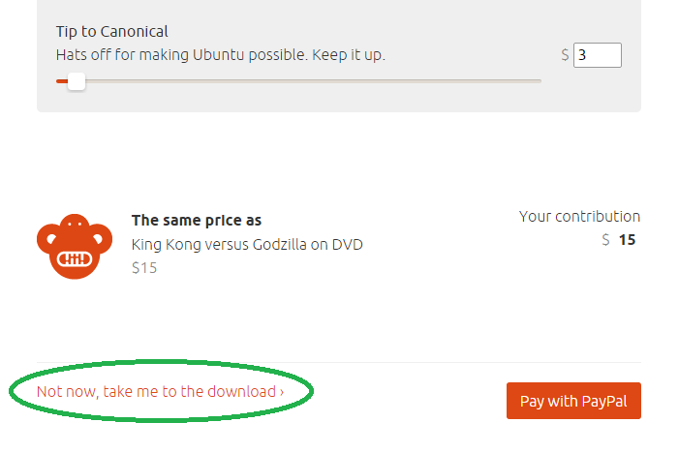
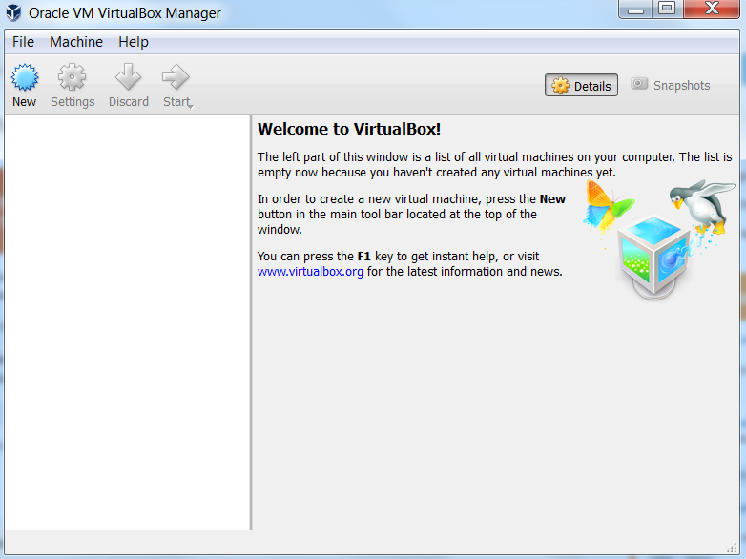
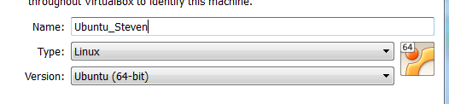
* The version doesn't matter for this demo, but here's what it means: Even numbered versions (marked “LTS”) have long-term support guaranteed. These are aimed at businesses who don't want to worry about having to update their operating system too often. Odd numbered versions do not have long-term support guaranteed.

* Choose 64-bit versions unless you are unsure of whether your computer is 32-bit or 64-bit, or if you know your computer is 32-bit. 32-bit operating systems can work on 64-bit hardware, but 64-bit cannot run on 32-bit hardware.

(Insert image of download page.)

Installing VirtualBox and making your first virtual machine
- Download VirtualBox from http://bit.ly/1OML8jl and run the installer.
- Click “Next” on all pages and “Install” on all security warning pop-ups until you see install and select it to begin installation.
- Click on new. For name put Ubuntu_YOURNAME. The type should be changed to Linux 64 bit. The version should be changed to Ubuntu 64 bit. If it didn’t change automatically look through the drop downs and select the choices that are pointed out above. Should look like the below picture:

* If you are using 32-bit, select 32-bit options instead.
- Allocate 1024 MB of ram. Click next. Click create image. Select Virtual Disk Image and click next. Select dynamically allocated and click next. Leave at default and click create.

Extra settings that are helpful and Installing an OS
- Click settings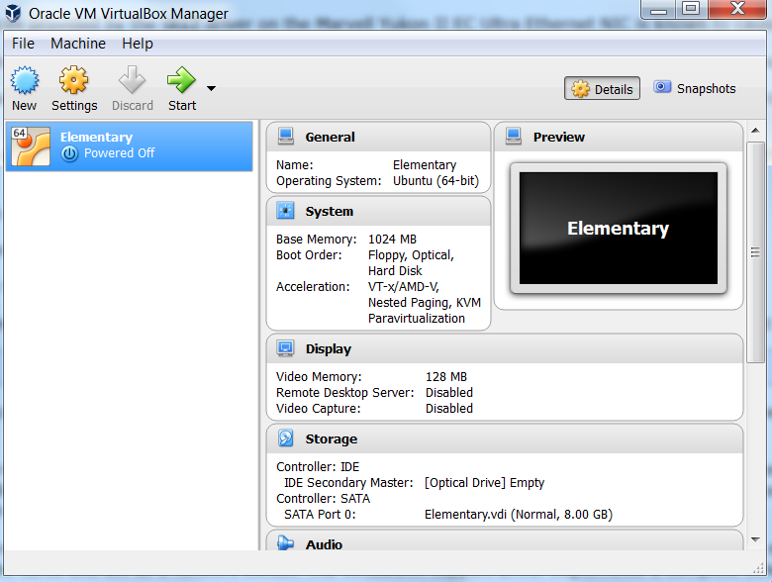
- Click on display on the side and add more video ram. This speeds up our image when we run the vm
- Go to networking and select bridged. This allows our vm to be found on our local network without anything else special being done.
- Go to system and make it dual core. This allows the vm to run a little better.
- Go to shared folder and make a shared folder. Click on auto-mount.
- Select the vm you made and click start. (This is assuming you already have your Ubuntu image)
- Browse using the tiny folder icon and look for the location of your downloaded image.
- Go through your operating systems installer.
*All the images above use Elementary instead of Ubuntu but that is the only difference. At the time of creation of this document Elementary had issues when running in VirtualBox

Installing Ubuntu
- Click on install ubuntu when prompted
- Then when prompted with updating and installing third party software leave then unchecked and continue
- At the installation type screen make sure only “erase and install ubuntu os” and “use lvm” (explain lvm and benefits)
- Select your correct timezone information
- Pick a name for the computer, username, and a password.

